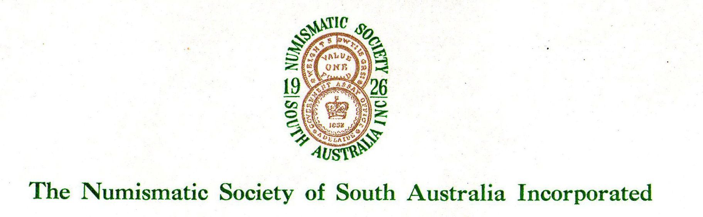

APPLICATION FOR MEMBERSHIP

I, …………………………………………………………………………………..
Full name

of…………………………………………………………………………………...
Address

……………………………………………………………………………………..

Email:……………………………………………Tel…………………………….

desire to become a member of The Numismatic Society of South Australia Inc
and agree to abide by its Rules and Regulations.

My numismatic interests are:

I enclose the sum of $A30- being the Annual Subscription.

Signature………………………………………………………Date……………..

Proposed by……………………………Seconded by……………………………

Approved by meeting dated………………………

Secretary………………………………………….

